A000-Am,C-Taino-Cemi-Anthrpomorphic-Hunchback with Bulging Eyes-Porphyritic Rhyolite-1000 CE

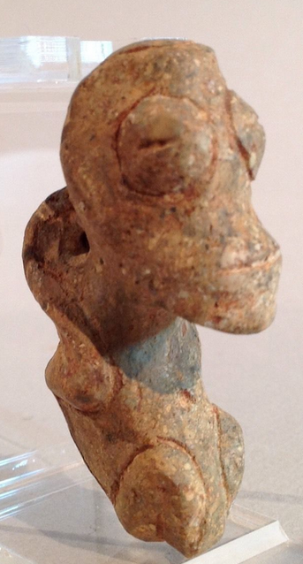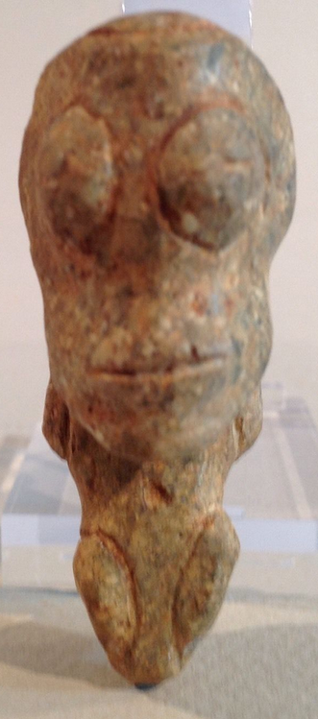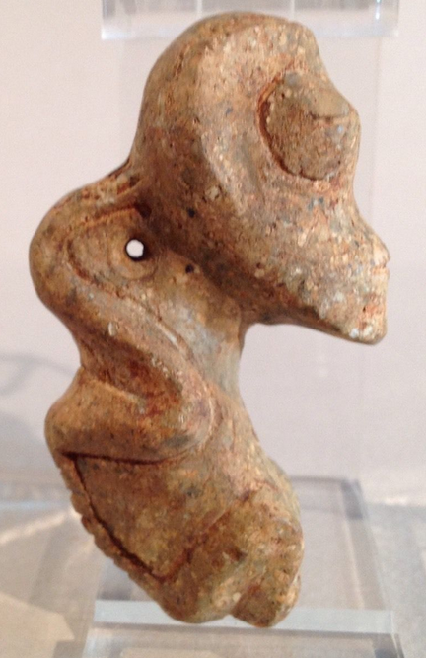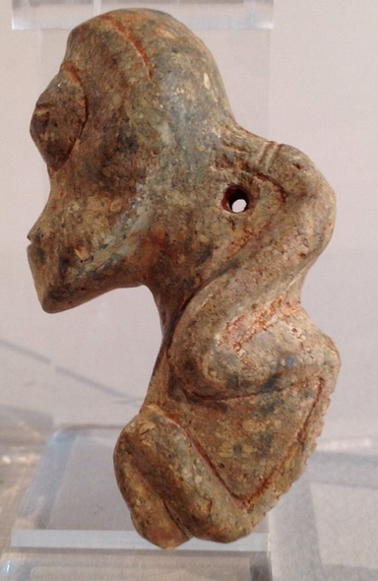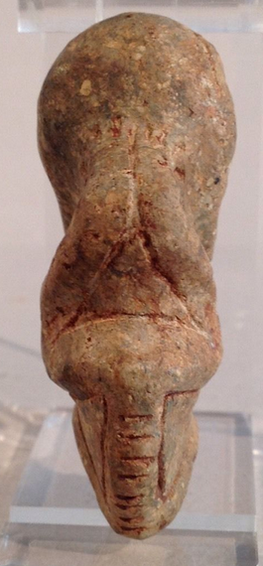

Figs. 1-5. Am,C-Taino-Cemi-Anthrpomorphic-Hunchback with Bulging Eyes-Porphyritic Rhyolite-1000 CE

**Case No.: 18**

**Accession No.**

**Formal Label:** Am,C-Taino-Cemi-Anthrpomorphic-Hunchback with Bulging Eyes-Porphyritic Rhyolite-1000 CE

**Display Description:**

This hunchback figure has bulging eyes and slightly bulging lips. The limbs are curvilinear with hands resting on back of head. Hunchback individuals, possibly dwarfs, were though to possess heightened spiritual powers, so that the bulging eyes should probably be interpreted as being the metaphor for heightened spiritual vision.

The markings of the spine on the back suggest the different levels of trance states.

The choice of porphyritic rhyolite was apropos of the subject since this color and its blotchy appearance due to crystal inclusions in the porphyritic rhyolite gives the appearance of a person in a trance state.

**LC Classification:**

**Date or Time Horizon:**

**Geographical Area:** Originally from the Dominican Republic

**Map:**

**GPS coordinates:**

**Cultural Affiliation:**

**Medium:** Made from porphyritic rhyolite.

**Dimensions:**

**Weight:**

**Condition:**

**Provenance:**

**Discussion:**

**References:**